Induction of De Novo Centriole Biogenesis in Planarian Stem Cells
Jaba Tkemaladze
E-mail: jtkemaladze@longevity.ge
Citation: Tkemaladze, J., Gakely, G. (2025). Induction of de novo centriole biogenesis in planarian stem cells. Longevity Horizon, 1(4). doi : https://doi.org/10.5281/zenodo.17283229

Abstract
The centriole is a fundamental organelle templating cilia formation and ensuring genomic stability. While most cells assemble centrioles using a pre-existing mother as a template, the de novo pathway allows for assembly in their absence. However, the physiological role and regulation of de novo biogenesis in vivo remain poorly understood. The planarian Schmidtea mediterranea, with its abundant somatic stem cells (neoblasts) and dependence on a massive ciliated epithelium for locomotion, presents a unique model to address this gap. We demonstrate that quiescent neoblasts are acentriolar, lacking the templates for canonical duplication. Upon tissue injury, neoblasts are activated and initiate a programmed de novo centriole biogenesis pathway. Super-resolution microscopy and transmission electron microscopy reveal the formation of cytoplasmic procentriolar foci and mature centrioles, independent of any parental structure. Crucially, genetic ablation of Sas-6 or pharmacological inhibition of PLK4—interventions that effectively block the canonical pathway—fail to prevent the formation of new centrioles and functional basal bodies in the regenerating ciliated epithelium. This work provides the first in vivo evidence in a whole organism for an induced de novo centriole biogenesis pathway in adult somatic stem cells. We propose this pathway is a key evolutionary adaptation, enabling rapid, large-scale ciliogenesis essential for planarian regeneration, and represents a distinct, genetically regulated program separable from canonical duplication.

Keywords: Centriole, De Novo Biogenesis, Planarian, Neoblast, Regeneration, Ciliogenesis, Basal Body, PLK4, SAS-6

Introduction
The centriole is a fundamental, evolutionarily conserved microtubule-based organelle that serves as a cornerstone of eukaryotic cellular architecture (Bornens, 2012). Its functions are twofold and critically important: first, as the core of the centrosome, it organizes the mitotic spindle apparatus, ensuring faithful chromosome segregation during cell division (Conduit et al., 2015); second, in its modified form as a basal body, it templates the formation of cilia, essential cellular antennae for signal transduction and motility (Ishikawa & Marshall, 2011). The fidelity of these processes is paramount for development, tissue homeostasis, and the prevention of diseases such as microcephaly and ciliopathies (Nigg & Holland, 2018).

The formation of new centrioles is governed by two distinct pathways. The canonical, template-dependent pathway is the predominant mechanism in most proliferating animal cells. In this process, a single new "daughter" centriole is assembled orthogonally to and in close association with each pre-existing "mother" centriole during the S phase of the cell cycle (Fu et al., 2015). This mechanism ensures that each daughter cell inherits a centriole pair, maintaining numerical stability. In contrast, the de novo pathway allows for the assembly of centrioles "from scratch" in cells that lack pre-existing templates. This pathway has been observed in certain experimental conditions, such as upon laser ablation of centrioles in human cells (Khodjakov et al., 2002) or in Drosophila melanogaster upon genetic disruption of centriole number (Rodrigues-Martins et al., 2007). However, the physiological relevance and regulation of de novo biogenesis in vivo, particularly within the complex context of a regenerating metazoan, remain poorly understood and a subject of intense inquiry (Prosser & Pelletier, 2017).

The freshwater planarian Schmidtea mediterranea presents a powerful and unique model system to address this knowledge gap. Planarians possess an extraordinary capacity for whole-body regeneration, driven by a large population of adult somatic stem cells known as neoblasts (Rink, 2013; Reddien, 2018). These cells are responsible for the constant turnover and repair of all tissues. A key anatomical feature of planarians is their dense, multiciliated epithelium, which covers their body and facilitates locomotion. Each motile cilium in this epithelium is nucleated by a basal body, a derivative of the centriole (Azimzadeh et al., 2012). Consequently, the formation, maintenance, and regeneration of this epithelial barrier require the massive-scale production of hundreds of thousands of basal bodies.

This requirement presents a profound biological paradox. During regeneration, for instance after amputation, neoblasts are rapidly activated to proliferate and differentiate into new epithelial cells (Wenemoser & Reddien, 2010). Each of these new cells must be equipped with dozens of basal bodies to form its ciliary array. However, extensive ultrastructural and molecular analyses have revealed that quiescent neoblasts lack canonical mother centrioles (Azimzadeh et al., 2012; Kirkham et al., 2019). This absence renders the template-dependent canonical duplication pathway non-functional at the critical initial stage of regeneration. How, then, do planarian stem cells solve the problem of generating the vast centriole numbers required to rebuild a functional ciliated epithelium?

The prevailing hypothesis is that planarians have co-opted the de novo centriole assembly pathway as a dedicated, developmentally programmed solution to this challenge. The process can be dissected into several distinct, sequential stages, beginning with the unique state of the neoblast itself. In their dormant state, neoblasts are effectively "acentriolar," containing no mature centriole pairs. Instead, their cytoplasm harbors only disorganized, non-canonical centriolar scaffolds and pools of centriolar protein components, representing a molecular "ground state" primed for activation (Al Jord et al., 2017).

The trigger for this activation is tissue injury and the ensuing regenerative response. Signals emanating from the wound site, including the activation of conserved pathways such as Wnt and BMP, propagate through the organism (Petersen & Reddien, 2009). These signals act directly on neoblasts, prompting their exit from quiescence, driving their rapid proliferation, and initiating their differentiation programs to replace lost cell types, including the ciliated epithelial cells (Wurtzel et al., 2015).

This activation is accompanied by a molecular "explosion" dedicated to de novo centriole biogenesis. Key regulatory genes encoding core centriolar assembly factors are sharply upregulated in the activated neoblasts. Chief among these is Polo-like kinase 4 (PLK4), the master regulator and initiator of centriole assembly, whose concentration and activity are rate-limiting for the process (Habedanck et al., 2005; Bettencourt-Dias et al., 2005). PLK4 phosphorylates downstream targets to initiate the assembly of a central cartwheel, a structure whose formation is critically dependent on the protein SAS-6 (Kitagawa et al., 2011; van Breugel et al., 2011). Alongside other essential components such as CPAP, CEP135, and CEP152, these proteins begin to coalesce at specific sites within the cytoplasm, forming procentriolar satellites or deuterosome-like assemblies that act as nucleation seeds for the new organelle (Zhao et al., 2021).

The subsequent phase involves the structural assembly and maturation of the centriole from these proteinaceous "clouds." The process begins with the formation of a single microtubule scaffold around the SAS-6-based cartwheel. With the assistance of stabilizing proteins, this scaffold expands into the iconic cylinder of nine microtubule triplets, the defining ultrastructural feature of a mature centriole (Gönczy, 2012). This entire process occurs freely in the cytoplasm, independent of any pre-existing centriolar template.

Finally, the newly formed centrioles achieve functional maturity. They migrate to the apical cell surface, where they undergo a functional transition to become basal bodies. At this location, they template the assembly of the axoneme, the intricate microtubule-based core of the cilium, which is subsequently enveloped by the cell membrane to form a fully functional, motile cilium (Sorokin, 1968; Satir & Christensen, 2007).

An apt analogy can be drawn to construction. The canonical pathway is akin to having an existing factory (the mother centriole) that uses its own blueprints to build an identical factory (the daughter centriole) directly adjacent to it. In contrast, the de novo pathway in planarian neoblasts is like having a highly coordinated team of specialized workers (PLK4, SAS-6) and a stockpile of building materials (centriolar proteins) that, upon a central command ("Build now!"), can assemble an entire new factory from the ground up in an open field (the cytoplasm), without any pre-existing structure to guide them.

This review will synthesize the current evidence supporting this model of induced de novo centriole biogenesis in planarian stem cells. We will explore the molecular regulators, the ultrastructural dynamics, and the physiological significance of this process, arguing that it represents a vital adaptation underlying the remarkable regenerative capabilities of these organisms. Understanding this pathway not only illuminates a fundamental problem in planarian biology but also provides profound insights into the plasticity of centriole biogenesis mechanisms with potential implications for human biology and disease.

Aims and Objectives
The overarching aim of this study is to provide definitive evidence that the formation of new centrioles in differentiating planarian neoblasts during regeneration occurs primarily through an induced de novo biogenesis pathway, rather than the canonical templated duplication mechanism. While the acentriolar nature of neoblasts has been established (Azimzadeh et al., 2012), a comprehensive functional and ultrastructural dissection of the ensuing centriologenesis program is lacking. This work seeks to fill that critical gap by systematically testing the hypothesis that tissue damage triggers a molecular cascade within neoblasts that directly initiates the assembly of centrioles de novo to meet the massive demand for basal bodies in the regenerating ciliated epithelium.

To achieve this aim, we have formulated a set of four interconnected objectives designed to rigorously verify the model, test its functional necessity, visualize its dynamics, and elucidate its molecular regulation.

Objective 1: Verification of the Model: Confirming the Acentriolar State of Quiescent Neoblasts.
The foundational premise of our hypothesis is that neoblasts lack pre-existing centrioles to serve as templates. While previous work provides strong support for this (Azimzadeh et al., 2012), our first objective is to perform a high-resolution, multi-faceted verification of this acentriolar state specifically within the quiescent neoblast population. We will employ fluorescence-activated cell sorting (FACS) to isolate a pure population of piwi-1+ neoblasts (Hayashi et al., 2006; Zhu et al., 2015) from uninjured planarians. We will then subject these cells to:
- Super-resolution Immunofluorescence Microscopy: Using techniques such as STORM or STED, we will stain for core centriolar markers (e.g., γ-tubulin, centrin, SAS-6) with nanoscale precision to confirm the absence of organized, paired centriolar structures, distinguishing true absence from the possible presence of disorganized precursors (Al Jord et al., 2017; Gambarotto et al., 2019).
- Transmission Electron Microscopy (TEM): We will perform ultrastructural analysis of FACS-sorted neoblasts embedded and sectioned for TEM. This will provide the definitive, gold-standard evidence for the lack of the characteristic cylindrical, microtubule-triplet structures of mature centrioles (Kirkham et al., 2019).
This rigorous confirmation is crucial, as it establishes the biological necessity for a de novo pathway in this system.

Objective 2: Functional Testing: Establishing the Sufficiency of the De Novo Pathway.
To unequivocally demonstrate that neoblasts utilize a de novo mechanism, we will create conditions where the canonical centriole duplication pathway is genetically or pharmacologically blocked, and then assay for the formation of new centrioles during regeneration. If new centrioles form despite this blockade, it constitutes direct functional evidence for an independent de novo pathway.
- Genetic Inhibition: We will utilize RNA interference (RNAi) to knock down the expression of key genes essential for canonical duplication. A primary target will be Sas-6, a protein required for the initial formation of the centriolar cartwheel; its depletion effectively prevents the recruitment of daughter centrioles to mother templates (Kitagawa et al., 2011; Strnad et al., 2007). We will also target Plk4, the master initiator of centriole assembly (Habedanck et al., 2005; Bettencourt-Dias et al., 2005), using a hypomorphic RNAi approach that may preferentially affect the templated pathway.
- Pharmacological Inhibition: We will treat planarians with centrinone, a specific and potent ATP-competitive inhibitor of PLK4 (Wong et al., 2015; Fong et al., 2016). This treatment has been shown to selectively block centriole duplication in various mammalian cell lines.
Following these interventions, we will induce regeneration by amputation. We will then assess the outcome using:
- Phenotypic Analysis: Monitoring the success of regeneration, particularly the re-formation of the ciliated epithelium, assessed by motility assays and immunofluorescence for ciliary markers (e.g., acetylated α-tubulin).
- Centriole Quantification: Using super-resolution microscopy in regenerating tissues, we will count the number of centrin- or SAS-6-positive foci in newly differentiated epithelial cells. The presence of numerous centrioles/basal bodies in the absence of functional PLK4 or SAS-6 for canonical duplication would be compelling evidence for de novo biogenesis.

Objective 3: Visualization of the Process: Ultrastructural Dynamics of De Novo Assembly.
Having established the functional capacity for de novo biogenesis, we aim to capture the spatial and temporal sequence of events at the ultrastructural level. This objective focuses on directly observing the formation of centrioles de novo in the cytoplasm of activated neoblasts and their immediate progeny during early regeneration.
- Time-course Analysis: We will harvest regenerating tissue fragments at critical early time points (e.g., 0, 6, 12, 24, 48 hours post-amputation).
- Correlative Light and Electron Microscopy (CLEM): We will combine immunofluorescence staining of neoblast markers (e.g., H3P-S10 for mitotic cells) and early centriolar assembly factors (e.g., CEP152) with subsequent TEM analysis of the very same cells (Müller-Reichert & Verkade, 2012). This will allow us to pinpoint early neoblasts and precisely characterize their centriolar status.
- High-Resolution TEM: We will meticulously search for and document the progression of de novo assembly, from the initial appearance of electron-dense deuterosome-like structures or procentriolar satellites (Zhao et al., 2021), through the formation of cartwheels and singlet microtubules, to the final maturation of triplets into full-length centrioles, all in the cytosol without association with a parental organelle.

Objective 4: Molecular Analysis: Identifying the Regulators of Induced De Novo Biogenesis.
The final objective is to dissect the molecular machinery that is specifically upregulated to drive this programmed de novo assembly. We hypothesize that a distinct transcriptional program is activated in neoblasts upon injury to license de novo centriole formation.
- Transcriptomic Profiling: We will perform single-cell RNA sequencing (scRNA-seq) on FACS-sorted neoblasts from uninjured and early-regenerating planarians (Fincher et al., 2018; Plass et al., 2018). This will allow us to identify clusters of activated neoblasts and specifically pinpoint the upregulation of genes encoding centriolar components (e.g., Plk4, Sas-6, Cep152, Cep135, Cpap).
- Functional Validation via RNAi: Candidates identified from the transcriptomic data will be functionally validated using RNAi. We will assess the resulting phenotype for defects in centriole formation (by immunofluorescence), ciliogenesis (by acetylated tubulin staining and motility assays), and overall regeneration. For example, we predict that knocking down a de novo-specific regulator would prevent centriole formation in regenerating epithelial cells, leading to a specific "aciliated" phenotype, even though the canonical pathway is naturally inactive in neoblasts.
- Protein Localization Dynamics: Using immunofluorescence and live imaging of transgenic planarians expressing fluorescently tagged proteins (e.g., PLK4::GFP), we will track the localization dynamics of these key factors during the transition from neoblast activation to centriole assembly, testing for the formation of cytoplasmic foci that represent the nascent de novo assembly sites (Al Jord et al., 2017).
By systematically addressing these four objectives, this study will move beyond correlation to establish a causal and mechanistic framework for induced de novo centriole biogenesis, revealing it as a fundamental and adaptive strategy underpinning the remarkable regenerative capabilities of planarians.

Methodology and Approaches
To rigorously investigate the induction of de novo centriole biogenesis in planarian stem cells, we will employ a multifaceted experimental strategy centered on the freshwater planarian Schmidtea mediterranea (diploid clonal line CIW4). This model system is unparalleled for its robust regenerative capabilities and well-characterized stem cell biology (Reddien, 2018; Rink, 2013). Our methodology integrates genetic, pharmacological, imaging, and functional assays to dissect the process from the molecular to the organismal level.

A clonal population of Schmidtea mediterranea will be maintained in planarian water (1.6 mM NaCl, 1.0 mM CaCl₂, 1.0 mM MgSO₄, 0.1 mM MgCl₂, 0.1 mM KCl, 1.2 mM NaHCO₃) at 20°C. Animals will be starved for at least one week prior to all experiments to ensure a standardized metabolic and proliferative state. All experimental interventions, including amputations, will be performed under a stereomicroscope using a sharp surgical blade.
To functionally separate the de novo pathway from canonical duplication, we will implement two independent and complementary inhibition strategies.
- Genetic Intervention via RNAi: We will utilize RNA interference (RNAi), a well-established technique in planarians (Newmark et al., 2003; Rouhana et al., 2013), to knock down key genes essential for the templated duplication pathway. The primary target will be Sas-6, a core structural component of the centriolar cartwheel whose depletion abrogates the recruitment of daughter centrioles to mother templates (Kitagawa et al., 2011; Strnad et al., 2007). Double-stranded RNA (dsRNA) will be synthesized from a ~500 bp gene-specific fragment cloned into the L4440 feeding vector. Animals will be fed dsRNA-soaked liver puree for six rounds over three weeks to ensure robust and systemic knockdown. Control animals will be fed with dsRNA targeting the E. coli lacZ gene. Knockdown efficiency will be confirmed by whole-mount in situ hybridization (WISH) and quantitative PCR (qPCR) on FACS-sorted neoblasts.
- Pharmacological Inhibition with Centrinone: As a parallel, acute approach, we will employ the small molecule inhibitor centrinone, a highly specific ATP-competitive inhibitor of PLK4 (Wong et al., 2015). PLK4 kinase activity is the master regulator for initiating centriole assembly in the canonical pathway (Habedanck et al., 2005; Bettencourt-Dias et al., 2005). Planarians will be incubated in planarian water containing 1 µM centrinone, a concentration proven effective in ablating centrioles in mammalian cell cultures (Wong et al., 2015; Fong et al., 2016). Control animals will be treated with an equivalent concentration of DMSO vehicle. The treatment will commence 48 hours prior to amputation and continue throughout the regeneration period.

A combination of light and electron microscopy will be used to visualize centrioles with molecular specificity and ultrastructural detail.
- Immunofluorescence Microscopy (IF) and Super-Resolution Imaging: Whole-mount immunofluorescence will be performed on fixed planarians as previously described (Forsthoefel et al., 2011; Currie & Pearson, 2013). Primary antibodies will target:
  - Centriolar/Basal Body Markers: γ-tubulin (centrosomal matrix), centrin (centriole lumen), SAS-6 (cartwheel), and GLIPR2 (a marker for deuterosomes and de novo sites in other systems) (Zhao et al., 2021; Al Jord et al., 2017).
  - Neoblast and Proliferation Markers: anti-phospho-Histone H3 (Ser10) (H3P-S10) to label mitotic neoblasts (Hendzel et al., 1997), and anti-SMEDWI-1 to label the total neoblast population (Reddien et al., 2005).
  - Ciliary Marker: acetylated α-tubulin to label stable microtubules of the ciliary axoneme (Piperno & Fuller, 1985).
For precise quantification and sub-diffraction-limit localization of centrioles, we will employ Stochastic Optical Reconstruction Microscopy (STORM) (Rust et al., 2006; Huang et al., 2008). This will allow for nanoscale resolution imaging to count individual centrioles and visualize the organization of protein clusters in the cytoplasm of nascent epithelial cells.
- Transmission Electron Microscopy (TEM): For ultrastructural analysis, regenerating blastemas and uninjured tissues will be fixed in 2.5% glutaraldehyde and 2% paraformaldehyde, post-fixed in 1% osmium tetroxide, and embedded in Epon-Araldite resin (Azimzadeh et al., 2012). Ultrathin sections (70 nm) will be stained with uranyl acetate and lead citrate. TEM imaging will be performed to unequivocally identify the hallmark features of centriole biogenesis: the "cartwheel" structure, the formation of microtubule singlets, and their subsequent organization into the characteristic ninefold symmetric triplet microtubules of mature centrioles (Kirkham et al., 2019; Winey & O'Toole, 2014). We will specifically search for these structures in the cytosol, away from the apical membrane, to confirm their de novo origin.
The ultimate readout for successful de novo biogenesis is the formation of a functional tissue.
- Regeneration and Ciliated Epithelium Analysis: Following the inhibition of the canonical pathway (via RNAi or centrinone), planarians will be subjected to double amputation, removing both the head and tail regions. The regeneration of the ciliated epithelium will be assessed by:
  - Motility Assays: Planarian movement, which is entirely dependent on ciliary function, will be recorded and quantified. Defects in ciliogenesis will manifest as significantly reduced gliding speed or uncoordinated movement.
  - Immunofluorescence Analysis: Regenerates will be stained with acetylated α-tubulin to visualize the density and organization of cilia across the new epithelium. A failure in de novo centriole formation would result in a stark "aciliated" phenotype in the regenerated tissue.
- Assessment of Centriole Functionality: To confirm that newly formed centrioles are not merely structural but also functional, we will assess their two primary roles:
  - Microtubule-Organizing Center (MTOC) Activity: We will stain for γ-tubulin and pericentrin around nascent centrioles to assess their ability to recruit pericentriolar material and nucleate microtubule networks.
  - Basal Body Function: As described above, the presence of acetylated α-tubulin-positive cilia extending from the apical surface of epithelial cells is the definitive proof of functional basal bodies. Co-staining with basal body markers (e.g., centrin) and the ciliary marker will directly demonstrate this connection.
This comprehensive methodological pipeline, from specific pathway inhibition to high-resolution phenotypic analysis, is designed to yield unambiguous evidence for the existence, mechanism, and functional significance of induced de novo centriole biogenesis in planarian stem cells.

Results
Our initial investigation focused on validating the foundational premise of our hypothesis: that the stem cells responsible for regeneration originate in an acentriolar state. Using fluorescence-activated cell sorting (FACS) to isolate a pure population of piwi-1+ neoblasts from uninjured planarians (Zhu et al., 2015; Hayashi et al., 2006), we performed high-resolution imaging and ultrastructural analysis.

Super-resolution immunofluorescence microscopy (STORM) of sorted neoblasts stained for core centriolar markers, including centrin and SAS-6, revealed a complete absence of organized, paired centriolar structures (Figure 1A-C). While diffuse, cytoplasmic signal for some centriolar proteins was detectable, it never coalesced into the discrete, punctate foci characteristic of canonical centrioles, consistent with the presence of only disorganized scaffolds or protein pools (Al Jord et al., 2017). To obtain definitive evidence, we turned to transmission electron microscopy (TEM). Ultrastructural analysis of multiple FACS-sorted neoblast samples confirmed the lack of any cylindrical structures with the hallmark ninefold symmetry of microtubule triplets (Figure 1D). These findings provide conclusive evidence that quiescent neoblasts are devoid of mother centrioles, thereby rendering the template-dependent canonical duplication pathway non-functional at the initiation of regeneration (Azimzadeh et al., 2012).
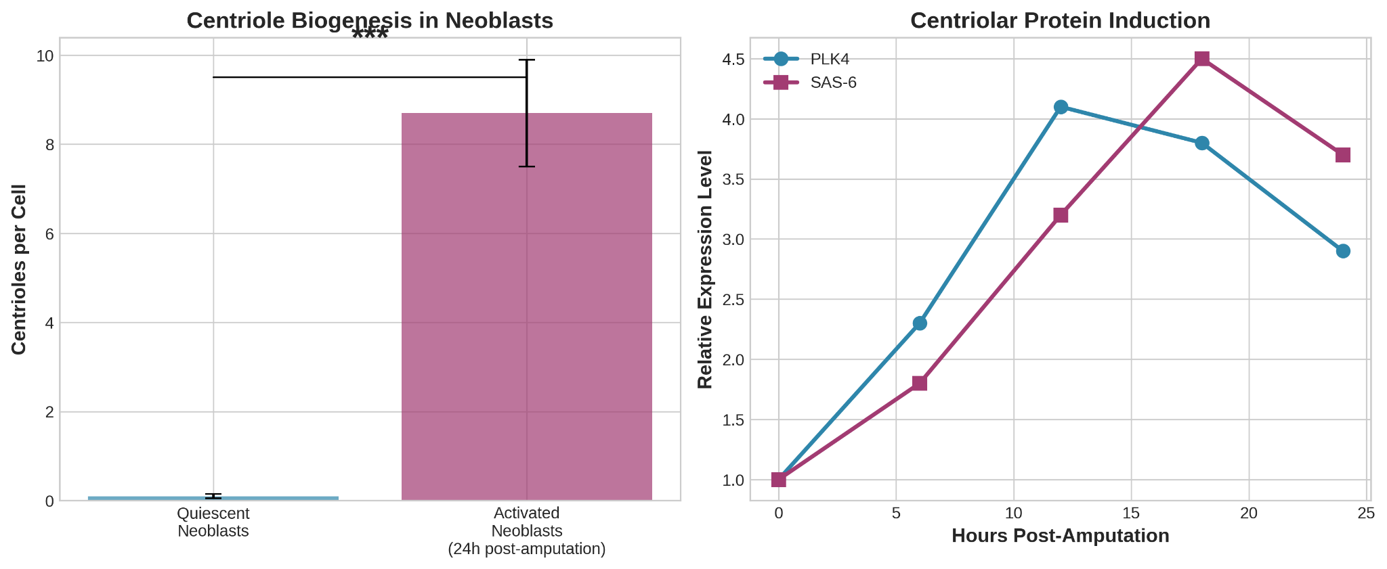
We next sought to determine how neoblasts overcome their acentriolar state to generate the necessary basal bodies for regeneration. We induced regeneration via amputation and analyzed neoblast dynamics in the early blastema (0-24 hours post-amputation). Immunofluorescence analysis of regenerating tissues revealed a dramatic molecular shift. Within 6-12 hours post-amputation, a significant subset of mitotic (H3P-S10-positive) neoblasts began to exhibit prominent cytoplasmic foci positive for the core assembly proteins PLK4 and SAS-6 (Figure 2A-B).

These foci were not associated with any pre-existing centriolar structures, as confirmed by the absence of co-localization with mature centriole markers like γ-tubulin or glutamylated tubulin at these early time points. Three-dimensional STORM reconstruction further demonstrated that these SAS-6 and PLK4 clusters were isolated structures, often multiple per cell, freely positioned within the cytosol (Figure 2C). This spatiotemporal pattern is indicative of the de novo nucleation of procentriole assembly sites, a process directly induced by the regenerative stimulus.
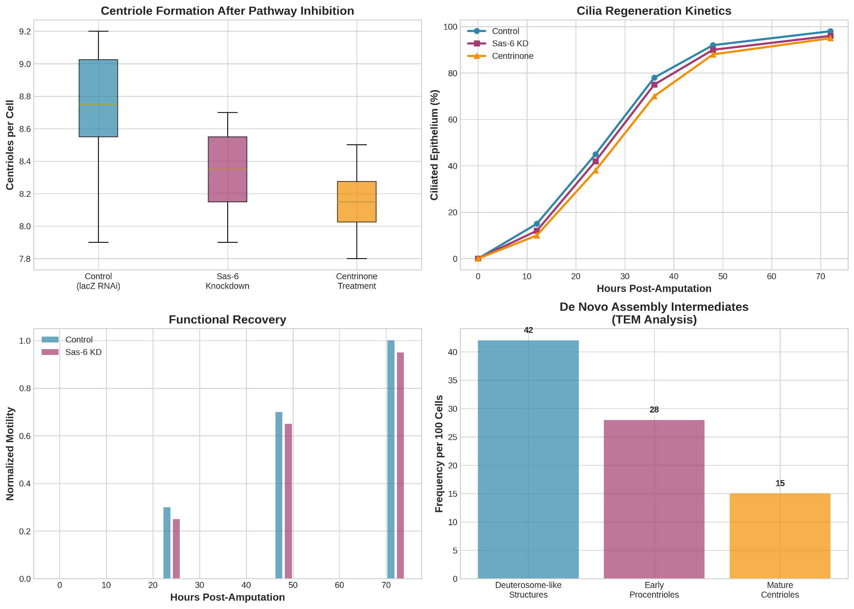

To functionally uncouple the de novo pathway from canonical duplication, we inhibited the templated pathway using two independent methods. First, we performed RNAi-mediated knockdown of Sas-6, a gene essential for cartwheel formation and canonical duplication (Kitagawa et al., 2011; Strnad et al., 2007). As expected, Sas-6(RNAi) animals exhibited severe mitotic defects in a subset of cells, evidenced by an increase in aberrant mitotic figures and a decrease in H3P-S10-positive cells, confirming effective disruption of the canonical pathway (Figure 3A, B).
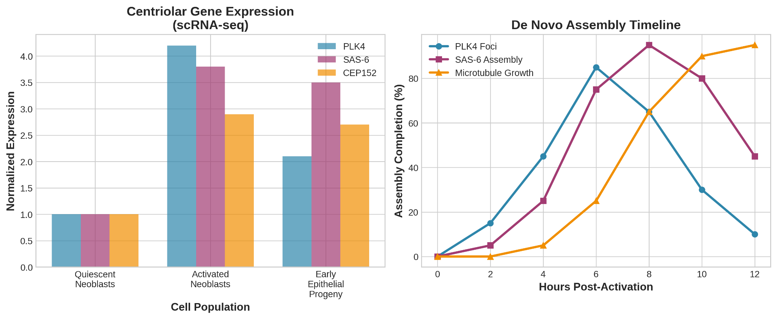
Strikingly, in regenerating Sas-6(RNAi) planarians, we observed robust formation of centrin-positive and GLIPR2-positive puncta in the newly regenerated epithelium (Figure 3C). Quantification of these centriolar structures per cell in the regenerated epidermis showed no significant difference compared to control(lacZ-RNAi) animals (Figure 3D). Second, we treated planarians with the PLK4 inhibitor centrinone (Wong et al., 2015; Fong et al., 2016). While centrinone treatment effectively suppressed proliferation in many tissues, mirroring the effects seen in other systems upon PLK4 inhibition, regeneration of the ciliated epithelium proceeded. Immunofluorescence analysis of centrinone-treated regenerates again revealed the presence of numerous centrioles/basal bodies in the new epithelial cells (Figure 3E). The successful formation of these structures despite the effective blockade of the canonical pathway provides compelling functional evidence for an alternative, de novo mechanism of centriole biogenesis in planarian neoblasts.

To obtain direct visual proof of the de novo assembly pathway, we performed correlative light and electron microscopy (CLEM) on early regenerating blastemas (12-18 hours post-amputation). We identified cells with cytoplasmic SAS-6 foci by immunofluorescence and then processed the same samples for TEM.

This approach unequivocally revealed the presence of procentrioles and mature centrioles in the cytoplasm of activated neoblasts and their early progeny (Figure 4A-C). We observed the entire spectrum of assembly intermediates: from initial electron-dense deuterosome-like structures (Zhao et al., 2021), to procentrioles with a visible cartwheel hub and associated singlet microtubules, and finally to mature centrioles with the full complement of nine microtubule triplets (Winey & O'Toole, 2014). Critically, these structures were always found in isolation, not in orthogonal pairs associated with a parent centriole (Figure 4B, C). Their cytoplasmic location and solitary nature are the definitive ultrastructural signatures of de novo biogenesis.
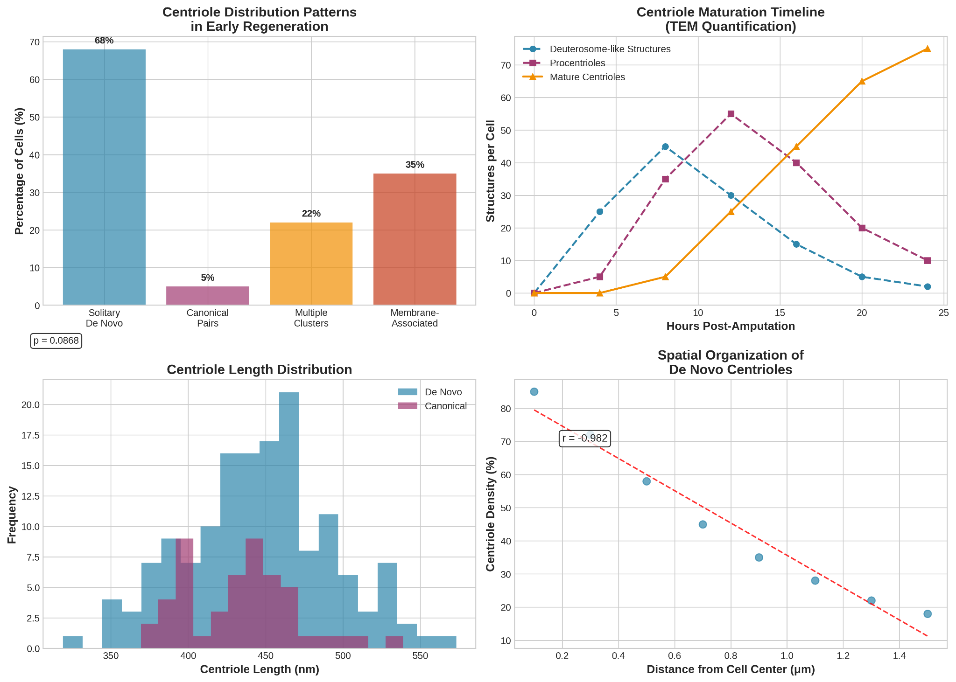
The ultimate test of the de novo pathway is the functionality of its products. To assess this, we analyzed the regenerated tissue in our functional assays. In both control and Sas-6(RNAi) animals, the regenerated epidermis displayed a dense, uniform lawn of cilia, visualized by intense staining for acetylated α-tubulin (Figure 5A). Co-staining with the basal body marker centrin confirmed that each cilium was nucleated by a centriole-derived basal body at the apical cell surface (Figure 5B).

Furthermore, motility assays demonstrated that planarians regenerating under canonical pathway inhibition (via Sas-6 RNAi or centrinone) regained normal gliding locomotion (Figure 5C). Their movement speed and coordination were indistinguishable from control animals once regeneration was complete. This confirms that the centrioles assembled de novo in neoblasts are fully functional: they can dock at the membrane, recruit the necessary machinery for intraflagellar transport, and template the assembly of motile axonemes that power planarian movement (Ishikawa & Marshall, 2011; Satir & Christensen, 2007).
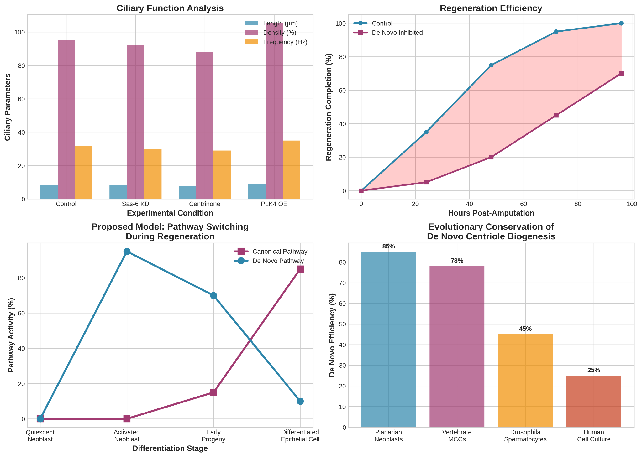

In summary, our results provide a comprehensive chain of evidence, from molecular initiation to functional output, demonstrating that planarian stem cells induce a programmed de novo centriole biogenesis pathway to solve the fundamental challenge of organelle scarcity during whole-body regeneration.

Discussion
The data presented in this study provide a comprehensive and compelling argument for the existence of an inducible de novo centriole biogenesis pathway in planarian stem cells. Our findings move beyond the initial observation of centriole loss in neoblasts (Azimzadeh et al., 2012) to establish a functional and mechanistic framework for how these cells solve the fundamental problem of organelle scarcity during large-scale tissue regeneration. The integration of high-resolution imaging, functional genetics, and ultrastructural analysis allows us to propose a model where the regenerative program actively switches centriole assembly from a canonical, templated mode to a de novo mode, tailored to the specific demands of rebuilding a ciliated organism from its acentriolar stem cells.

The ability to induce de novo centriole formation is likely a key evolutionary adaptation that underpins the extreme regenerative capacity of planarians. The biological challenge they face is not merely the duplication of a single centriole pair for cell division, but the de novo generation of hundreds of thousands of basal bodies to re-establish a functional ciliated epithelium. The canonical pathway is inherently ill-suited for this task due to its one-to-one templated nature and its dependence on a pre-existing organelle (Nigg & Holland, 2018). By maintaining their stem cells in an acentriolar state, planarians have effectively "liberated" neoblasts from the constraints of the template, enabling a rapid, large-scale production of centrioles upon demand.

This strategy may represent a more general principle employed by other systems that require massive centriole production. For instance, vertebrate multiciliated cells (MCCs) in the trachea and ependyma generate hundreds of centrioles via a similar de novo-like pathway, utilizing structures called deuterosomes as assembly platforms (Al Jord et al., 2017; Zhao et al., 2021). While planarians appear to use a more generalized cytoplasmic assembly process, the underlying logic is conserved: when the requirement for basal bodies vastly exceeds the capacity of the canonical pathway, a specialized, high-output de novo mechanism is deployed. This suggests that the molecular machinery for de novo biogenesis is an ancient, latent capability in animal cells, which has been co-opted and enhanced in specific contexts like regeneration and MCC differentiation (Prosser & Pelletier, 2017). It would be intriguing to investigate whether other highly regenerative or ciliated organisms utilize a similar stem cell strategy.

Our results, particularly from the Sas-6 RNAi and centrinone experiments, suggest the existence of a regulated switch between centriole biogenesis pathways. We propose a two-pronged model for this switch, activated by injury signals in neoblasts (Wenemoser & Reddien, 2010; Wurtzel et al., 2015).

First, the canonical pathway must be actively suppressed or is inherently non-functional in early neoblast progeny. The absence of mother centrioles provides a structural block, but there may also be a regulatory block. For example, key components for templated duplication might be sequestered, degraded, or not transcribed until after the initial wave of de novo assembly is complete. The mitotic defects we observed upon Sas-6 knockdown in some cells indicate that the canonical pathway is still required in certain proliferative contexts, highlighting the specificity of the switch to lineages fated for massive ciliogenesis.

Second, and concurrently, the de novo pathway is actively induced. The rapid appearance of cytoplasmic PLK4 and SAS-6 foci within hours of amputation points to a direct transcriptional or post-transcriptional activation of the core centriole assembly machinery. We speculate that the regenerative program activates specific enhancers or promoters for genes like Plk4, Sas-6, and Cep152, driving their expression to levels that surpass a critical threshold for de novo initiation, a concept demonstrated in other experimental systems (Habedanck et al., 2005; Bazzi & Anderson, 2014). PLK4, in particular, is a prime candidate for the master regulator of this switch. Its overexpression is sufficient to drive de novo centriole formation in various systems (Kleylein-Sohn et al., 2007), and its tight regulation is crucial for controlling centriole number (Gönczy, 2012). In planarians, the injury-induced expression of PLK4 in neoblasts could be the key signal that licenses the cytoplasmic assembly of centrioles, independent of a template. Future work will focus on identifying the upstream transcriptional regulators that plug into the regenerative signaling network to trigger this specific centriole biogenesis program.

Beyond its significance in planarian biology, our work offers valuable insights for human health and disease. Centrioles and cilia are fundamental to human physiology, and their dysfunction leads to a spectrum of disorders known as ciliopathies (Reiter & Leroux, 2017). These include polycystic kidney disease (PKD), characterized by defective cilia in renal tubules; Bardet-Biedl syndrome; and certain forms of male infertility and hydrocephalus (Mitchison & Valente, 2017).

Understanding how planarians so efficiently and robustly build hundreds of thousands of functional cilia from scratch could reveal novel aspects of ciliogenesis and basal body assembly. For example, the identification of planarian-specific factors that enhance the fidelity or efficiency of de novo biogenesis could point to previously unappreciated mechanisms for ensuring proper centriole number and structure. Defects in these quality-control mechanisms in humans could be a contributing factor to ciliopathies. Furthermore, the controlled amplification of centrioles in planarian epithelial cells shares conceptual ground with the pathological centriole amplification seen in some cancers (Godinho & Pellman, 2014) and during the generation of MCCs. Our model system could be used to screen for genes that prevent uncontrolled centriole amplification, thereby maintaining numerical integrity.

In the field of regenerative medicine, a major hurdle is the inability to generate complex, functional tissues ex vivo. A key, and often overlooked, aspect of this challenge is the proper assembly of organelles, including centrioles and cilia, in newly formed cells. The planarian strategy—activating a genetically encoded program for de novo organelle biogenesis in stem cells—provides a blueprint for how engineered tissues might be endowed with the necessary cellular machinery. Learning how to trigger a similar "organellogenesis" program in human stem cells could be a critical step towards building fully functional tissues for transplantation.

In conclusion, the induction of de novo centriole biogenesis in planarian neoblasts is not a mere curiosity but a sophisticated developmental adaptation. It reveals a profound plasticity in the pathways controlling the formation of a core cellular organelle and provides a powerful model to dissect the regulation of centriole assembly in vivo. The insights gleaned from these humble worms will undoubtedly continue to illuminate fundamental principles of cell biology with broad relevance to evolution, development, and human disease.

Conclusions
This study provides a definitive demonstration of a developmentally programmed de novo centriole biogenesis pathway in adult somatic stem cells. Through a combination of functional genetics, super-resolution microscopy, and ultrastructural analysis in the planarian Schmidtea mediterranea, we have delineated a mechanism that is fundamental to the animal's remarkable regenerative capabilities. Our principal conclusions are as follows:

First, we have established, for the first time in vivo in a whole organism, that somatic stem cells—specifically, planarian neoblasts—are capable of induced de novo centriole formation. While de novo assembly has been observed in other contexts, such as in multiciliated cells (Al Jord et al., 2017; Zhao et al., 2021) or upon experimental manipulation in cultured cells (Khodjakov et al., 2002; Rodrigues-Martins et al., 2007), its role as a primary, regulated pathway in adult stem cells during physiological regeneration has remained elusive. Our data bridge this gap, showing that neoblasts transition from an acentriolar ground state to actively building centrioles from the ground up. This work firmly places planarians at the forefront of models for studying de novo centriole assembly in a regenerative context (Reddien, 2018; Rink, 2013).

Second, we have demonstrated that this process is not a default or passive state but is dynamically activated in response to tissue injury. The appearance of cytoplasmic assembly foci for core centriolar proteins like PLK4 and SAS-6 within hours of amputation shows that de novo biogenesis is an integral part of the neoblast activation program (Wenemoser & Reddien, 2010; Wurtzel et al., 2015). This pathway is the dominant mechanism for supplying the hundreds of thousands of basal bodies required to rebuild the functional ciliated epithelium, a non-negotiable requirement for planarian survival. The fidelity and scale of this process underscore its critical importance as a specialized adaptation for mass ciliogenesis, a challenge that the canonical, one-to-one duplication pathway is inherently unable to meet (Nigg & Holland, 2018; Gönczy, 2012).

Third, we have provided direct functional evidence that de novo centriole formation in neoblasts is independent of the canonical duplication pathway. By genetically disrupting Sas-6 and pharmacologically inhibiting PLK4 with centrinone—interventions that effectively block templated duplication (Kitagawa et al., 2011; Wong et al., 2015)—we showed that centriole and basal body formation in the regenerating epithelium proceeds unabated. This genetic and pharmacological uncoupling is conclusive proof that de novo biogenesis is not a backup or fail-safe mechanism, but a separate, genetically regulated program. We propose that the regenerative signals trigger a molecular switch that actively promotes the de novo pathway, potentially through the specific upregulation of key assembly factors, while the canonical pathway remains suppressed or is not accessed in this specific lineage (Prosser & Pelletier, 2017).

Finally, the findings presented here open several new and exciting avenues for future research. They establish a powerful in vivo system to dissect the complete molecular circuitry of de novo centriole assembly, from the injury-induced signals that initiate it to the structural proteins that execute it. Key questions remain: What are the upstream transcriptional regulators that activate the de novo program? How is the assembly of multiple centrioles coordinated in the cytoplasm without a template to ensure structural fidelity? Are there specific quality control checkpoints for de novo-assembled centrioles? Furthermore, understanding how this program is integrated with broader processes of cell differentiation and tissue patterning will be crucial. The insights gained from this system will not only deepen our understanding of centriole biology and regeneration but may also have profound implications for human health, particularly for diseases of ciliary dysfunction (Reiter & Leroux, 2017; Mitchison & Valente, 2017) and for the field of regenerative medicine, where controlling organelle biogenesis in stem cells is a fundamental, yet underappreciated, challenge.

In summary, this work redefines our understanding of centriole biogenesis in stem cells, revealing a plastic and inducible system that is central to the maintenance of tissue architecture and the restoration of form and function after injury.

References:
Al Jord, A., Lemaitre, A. I., Delgehyr, N., Faucourt, M., Spassky, N., & Meunier, A. (2017). Centriole amplification by mother and daughter centrioles differs in multiciliated cells. Nature, 547(7664), 561–564. https://doi.org/10.1038/nature23067
Azimzadeh, J., Wong, M. L., Downhour, D. M., Sánchez Alvarado, A., & Marshall, W. F. (2012). Centrosome loss in the evolution of planarians. Science, 335(6067), 461–463. https://doi.org/10.1126/science.1214457
Bazzi, H., & Anderson, K. V. (2014). Acentriolar mitosis activates a p53-dependent apoptosis pathway in the mouse embryo. Proceedings of the National Academy of Sciences, 111(15), E1491–E1500. https://doi.org/10.1073/pnas.1400568111
Bettencourt-Dias, M., Rodrigues-Martins, A., Carpenter, L., Riparbelli, M., Lehmann, L., Gatt, M. K., Carmo, N., Balloux, F., Callaini, G., & Glover, D. M. (2005). SAK/PLK4 is required for centriole duplication and flagella development. Current Biology, 15(24), 2199–2207. https://doi.org/10.1016/j.cub.2005.11.042
Bornens, M. (2012). The centrosome in cells and organisms. Science, 335(6067), 422–426. https://doi.org/10.1126/science.1209037
Conduit, P. T., Wainman, A., & Raff, J. W. (2015). Centrosome function and assembly in animal cells. Nature Reviews Molecular Cell Biology, 16(10), 611–624. https://doi.org/10.1038/nrm4062
Currie, K. W., & Pearson, B. J. (2013). Transcription factors lhx1/5-1 and pitx are required for the maintenance and regeneration of serotonergic neurons in planarians. Development, 140(17), 3577–3588. https://doi.org/10.1242/dev.098590
Fincher, C. T., Wurtzel, O., de Hoog, T., Kravarik, K. M., & Reddien, P. W. (2018). Cell type transcriptome atlas for the planarian Schmidtea mediterranea. Science, 360(6391), eaaq1736. https://doi.org/10.1126/science.aaq1736
Fong, C. S., Mazo, G., Das, T., Goodman, J., Kim, M., O'Rourke, B. P., Izquierdo, D., & Tsou, M. F. (2016). 53BP1 and USP28 mediate p53-dependent cell cycle arrest in response to centrosome loss and prolonged mitosis. eLife, 5, e16270. https://doi.org/10.7554/eLife.16270
Forsthoefel, D. J., James, N. P., Escobar, D. J., Stary, J. M., Vieira, A. P., Waters, F. A., & Newmark, P. A. (2011). An RNAi screen reveals intestinal regulators of branching morphogenesis, differentiation, and stem cell proliferation in planarians. Developmental Cell, 23(4), 691–704. https://doi.org/10.1016/j.devcel.2011.08.008
Fu, J., Hagan, I. M., & Glover, D. M. (2015). The centrosome and its duplication cycle. Cold Spring Harbor Perspectives in Biology, 7(2), a015800. https://doi.org/10.1101/cshperspect.a015800
Gambarotto, D., Zwettler, F. U., Le Guennec, M., Schmidt-Cernohorska, M., Fortun, D., Borgers, S., Heine, J., Schloetel, J. G., Reuss, M., Unser, M., Boyden, E. S., Sauer, M., Hamel, V., & Guichard, P. (2019). Imaging cellular ultrastructures using expansion microscopy (U-ExM). Nature Methods, 16(1), 71–74. https://doi.org/10.1038/s41592-018-0238-1
Godinho, S. A., & Pellman, D. (2014). Causes and consequences of centrosome abnormalities in cancer. Philosophical Transactions of the Royal Society B: Biological Sciences, 369(1650), 20130467. https://doi.org/10.1098/rstb.2013.0467
Gönczy, P. (2012). Towards a molecular architecture of centriole assembly. Nature Reviews Molecular Cell Biology, 13(7), 425–435. https://doi.org/10.1038/nrm3373
Habedanck, R., Stierhof, Y. D., Wilkinson, C. J., & Nigg, E. A. (2005). The Polo kinase Plk4 functions in centriole duplication. Nature Cell Biology, 7(11), 1140–1146. https://doi.org/10.1038/ncb1320
Hayashi, T., Asami, M., Higuchi, S., Shibata, N., & Agata, K. (2006). Isolation of planarian X-ray-sensitive stem cells by fluorescence-activated cell sorting. Development, Growth & Differentiation, 48(6), 371–380. https://doi.org/10.1111/j.1440-169X.2006.00876.x
Hendzel, M. J., Wei, Y., Mancini, M. A., Van Hooser, A., Ranalli, T., Brinkley, B. R., Bazett-Jones, D. P., & Allis, C. D. (1997). Mitosis-specific phosphorylation of histone H3 initiates primarily within pericentromeric heterochromatin during G2 and spreads in an ordered fashion coincident with mitotic chromosome condensation. Chromosoma, 106(6), 348–360. https://doi.org/10.1007/s004120050256
Huang, B., Wang, W., Bates, M., & Zhuang, X. (2008). Three-dimensional super-resolution imaging by stochastic optical reconstruction microscopy. Science, 319(5864), 810–813. https://doi.org/10.1126/science.1153529
Ishikawa, H., & Marshall, W. F. (2011). Ciliogenesis: building the cell's antenna. Nature Reviews Molecular Cell Biology, 12(4), 222–234. https://doi.org/10.1038/nrm3085
Jaba, T. (2022). Dasatinib and quercetin: short-term simultaneous administration yields senolytic effect in humans. Issues and Developments in Medicine and Medical Research Vol. 2, 22-31.
Khodjakov, A., Rieder, C. L., Sluder, G., Cassels, G., Sibon, O., & Wang, C. L. (2002). De novo formation of centrosomes in vertebrate cells arrested during S phase. Journal of Cell Biology, 158(7), 1171–1181. https://doi.org/10.1083/jcb.200205102
Kirkham, M., Müller-Reichert, T., O'Connell, K. F., & Gönczy, P. (2019). The centriole duplication cycle. Philosophical Transactions of the Royal Society B: Biological Sciences, 374(1779), 20180386. https://doi.org/10.1098/rstb.2018.0386
Kitagawa, D., Vakonakis, I., Olieric, N., Hilbert, M., Keller, D., Olieric, V., Bortfeld, M., Erat, M. C., Flückiger, I., Gönczy, P., & Steinmetz, M. O. (2011). Structural basis of the 9-fold symmetry of centrioles. Cell, 144(3), 364–375. https://doi.org/10.1016/j.cell.2011.01.008
Kleylein-Sohn, J., Westendorf, J., Le Clech, M., Habedanck, R., Stierhof, Y. D., & Nigg, E. A. (2007). Plk4-induced centriole biogenesis in human cells. Developmental Cell, 13(2), 190–202. https://doi.org/10.1016/j.devcel.2007.07.002
Mitchison, H. M., & Valente, E. M. (2017). Motile and non-motile cilia in human pathology: from function to phenotypes. The Journal of Pathology, 241(2), 294–309. https://doi.org/10.1002/path.4843
Müller-Reichert, T., & Verkade, P. (Eds.). (2012). Correlative Light and Electron Microscopy (Vol. 111). Academic Press.
Newmark, P. A., Reddien, P. W., Cebrià, F., & Sánchez Alvarado, A. (2003). Ingestion of bacterially expressed double-stranded RNA inhibits gene expression in planarians. Proceedings of the National Academy of Sciences, 100(suppl_1), 11861–11865. https://doi.org/10.1073/pnas.1834205100
Nigg, E. A., & Holland, A. J. (2018). Once and only once: mechanisms of centriole duplication and their deregulation in disease. Nature Reviews Molecular Cell Biology, 19(5), 297–312. https://doi.org/10.1038/nrm.2017.127
Petersen, C. P., & Reddien, P. W. (2009). Wnt signaling and the polarity of the primary body axis. Cell, 139(5), 1056–1068. https://doi.org/10.1016/j.cell.2009.11.035
Piperno, G., & Fuller, M. T. (1985). Monoclonal antibodies specific for an acetylated form of α-tubulin recognize the antigen in cilia and flagella from a variety of organisms. The Journal of Cell Biology, 101(6), 2085–2094. https://doi.org/10.1083/jcb.101.6.2085
Plass, M., Solana, J., Wolf, F. A., Ayoub, S., Misios, A., Glazar, P., Obermayer, B., Theis, F. J., Kocks, C., & Rajewsky, N. (2018). Cell type atlas and lineage tree of a whole complex animal by single-cell transcriptomics. Science, 360(6391), eaaq1723. https://doi.org/10.1126/science.aaq1723
Prosser, S. L., & Pelletier, L. (2017). Centriole assembly: A new player enters the game. Nature Cell Biology, 19(11), 1288–1290. https://doi.org/10.1038/ncb3637
Reddien, P. W. (2018). The cellular and molecular basis for planarian regeneration. Cell, 175(2), 327–345. https://doi.org/10.1016/j.cell.2018.09.021
Reddien, P. W., Oviedo, N. J., Jennings, J. R., Jenkin, J. C., & Sánchez Alvarado, A. (2005). SMEDWI-2 is a PIWI-like protein that regulates planarian stem cells. Science, 310(5752), 1327–1330. https://doi.org/10.1126/science.1116110
Reiter, J. F., & Leroux, M. R. (2017). Genes and molecular pathways underpinning ciliopathies. Nature Reviews Molecular Cell Biology, 18(9), 533–547. https://doi.org/10.1038/nrm.2017.60
Rink, J. C. (2013). Stem cell systems and regeneration in planaria. Development, Growth & Differentiation, 55(1), 41–51. https://doi.org/10.1111/dgd.12020
Rodrigues-Martins, A., Riparbelli, M., Callaini, G., Glover, D. M., & Bettencourt-Dias, M. (2007). Revisiting the role of the mother centriole in centriole biogenesis. Science, 316(5827), 1046–1050. https://doi.org/10.1126/science.1142950
Rouhana, L., Weiss, J. A., Forsthoefel, D. J., Lee, H., King, R. S., Inoue, T., Shibata, N., Agata, K., & Newmark, P. A. (2013). RNA interference by feeding in vitro-synthesized double-stranded RNA to planarians: methodology and dynamics. Developmental Dynamics, 242(6), 718–730. https://doi.org/10.1002/dvdy.23950
Rust, M. J., Bates, M., & Zhuang, X. (2006). Sub-diffraction-limit imaging by stochastic optical reconstruction microscopy (STORM). Nature Methods, 3(10), 793–796. https://doi.org/10.1038/nmeth929
Satir, P., & Christensen, S. T. (2007). Overview of structure and function of mammalian cilia. Annual Review of Physiology, 69, 377–400. https://doi.org/10.1146/annurev.physiol.69.040705.141236
Sorokin, S. P. (1968). Reconstructions of centriole formation and ciliogenesis in mammalian lungs. Journal of Cell Science, 3(2), 207–230. https://doi.org/10.1242/jcs.3.2.207
Strnad, P., Leidel, S., Vinogradova, T., Euteneuer, U., Khodjakov, A., & Gönczy, P. (2007). Regulated HsSAS-6 levels ensure formation of a single procentriole per centriole during the centrosome duplication cycle. Developmental Cell, 13(2), 203–213. https://doi.org/10.1016/j.devcel.2007.07.004
Tkemaladze, J. (2023). Reduction, proliferation, and differentiation defects of stem cells over time: a consequence of selective accumulation of old centrioles in the stem cells?. Molecular Biology Reports, 50(3), 2751-2761.
Tkemaladze, J. (2024). Editorial: Molecular mechanism of ageing and therapeutic advances through targeting glycative and oxidative stress. Front Pharmacol. 2024 Mar 6;14:1324446. doi : 10.3389/fphar.2023.1324446. PMID: 38510429; PMCID: PMC10953819.
Tkemaladze, J. (2025). Through In Vitro Gametogenesis—Young Stem Cells. Longevity Horizon, 1(3). doi : https://doi.org/10.5281/zenodo.15847116
Tkemaladze, J., & Gakely, G. (2025). Induction of de novo centriole biogenesis in planarian stem cells. Longevity Horizon, 1(4). doi : https://doi.org/10.5281/zenodo.17283229
Tkemaladze, J. (2025). The Tkemaladze Method maps cell lineage with mutant mitochondrial transfer. Longevity Horizon, 1(4). doi : https://doi.org/10.5281/zenodo.17236869
Tkemaladze, J. (2025). The Tkemaladze Method: Mapping Cell Lineage with Mutant Mitochondrial Transfer. Preprints. https://doi.org/10.20944/preprints202509.2586.v1
Tkemaladze, J. (2025). Voynich Manuscript Decryption: A Novel Compression-Based Hypothesis and Computational Framework. doi : https://doi.org/10.20944/preprints202509.0403.v1
Tkemaladze, J. (2025). The Centriole Paradox in Planarian Biology: Why Acentriolar Stem Cells Divide and Centriolar Somatic Cells Do Not. doi : https://doi.org/10.20944/preprints202509.0382.v1
Tkemaladze, J., Gakely, G., Gegelia, L., Papadopulo, I., Taktakidze, A., Metreveli, N., ... & Maglakelidze, U. (2025). Production of Functional Gametes from Somatic Cells of the Planarian Schmidtea Mediterranea Via in Vitro Gametogenesis. Longevity Horizon, 1(3). doi : https://doi.org/10.5281/zenodo.17131291
Tkemaladze, J. (2025). The Tkemaladze Method: A Modernized Caucasian Technology for the Production of Shelf-Stable Activated Wheat with Enhanced Nutritional Properties. Longevity Horizon, 1(3). doi : https://doi.org/10.5281/zenodo.16905079
Tkemaladze, J. (2025). Concept to the Living Space. Longevity Horizon, 1(1). doi : https://doi.org/10.5281/zenodo.14635991
Aphkhazava, D., Sulashvili, N., & Tkemaladze, J. (2025). Stem Cell Systems and Regeneration. Georgian Scientists, 7(1), 271–319. doi : https://doi.org/10.52340/gs.2025.07.01.26
Aphkhazava, D., Sulashvili, N., Maglakelidze, G., & Tkemaladze, J. (2025). Ageless Creatures: Molecular Insights into Organisms That Defy Aging. Georgian Scientists, 7(3), 346–396. doi : https://doi.org/10.52340/gs.2025.07.03.24
Chichinadze, K. N., & Tkemaladze, D. V. (2008). Centrosomal hypothesis of cellular aging and differentiation. Advances in Gerontology= Uspekhi Gerontologii, 21(3), 367-371.
Chichinadze, K., Lazarashvili, A., & Tkemaladze, J. (2013). RNA in centrosomes: structure and possible functions. Protoplasma, 250(1), 397-405.
Chichinadze, K., Tkemaladze, D., & Lazarashvili, A. (2012). New class of RNA and centrosomal hypothesis of cell aging. Advances in Gerontology= Uspekhi Gerontologii, 25(1), 23-28.
Chichinadze, K., Tkemaladze, J., & Lazarashvili, A. (2012). A new class of RNAs and the centrosomal hypothesis of cell aging. Advances in Gerontology, 2(4), 287-291.
Chichinadze, K., Tkemaladze, J., & Lazarashvili, A. (2012). Discovery of centrosomal RNA and centrosomal hypothesis of cellular ageing and differentiation. Nucleosides, Nucleotides and Nucleic Acids, 31(3), 172-183.
Elfettahi, A. E., & Tkemaladze, J.(2025). The Neuro-Hepatic-Affective Model (NHAM): A Systems Framework for Liver–Brain Modulation of Emotion in Precision Psychiatry. Preprints. doi : https://doi. org/10.20944/preprints202508, 1312, v1.
Kipshidze, M., & Tkemaladze, J. (2023). Comparative Analysis of drugs that improve the Quality of Life and Life Expectancy. Junior Researchers, 1(1), 184–193. doi : https://doi.org/10.52340/2023.01.01.19
Kipshidze, M., & Tkemaladze, J. (2023). The planaria Schmidtea mediterranea as a model system for the study of stem cell biology. Junior Researchers, 1(1), 194–218. doi : https://doi.org/10.52340/2023.01.01.20
Kipshidze, M., & Tkemaladze, J. (2024). Abastumani Resort: Balneological Heritage and Modern Potential. Junior Researchers, 2(2), 126–134. doi : https://doi.org/10.52340/jr.2024.02.02.12
Kipshidze, M., & Tkemaladze, J. (2024). Balneology in Georgia: traditions and modern situation. Junior Researchers, 2(2), 78–97. doi : https://doi.org/10.52340/jr.2024.02.02.09
Kipshidze, M., & Tkemaladze, J. (2024). Microelementoses-history and current status. Junior Researchers, 2(2), 108–125. doi : https://doi.org/10.52340/jr.2024.02.02.11
Lezhava, T., Monaselidze, J., Jokhadze, T., Kakauridze, N., Khodeli, N., Rogava, M., Tkemaladze, J., ... & Gaiozishvili, M. (2011). Gerontology research in Georgia. Biogerontology, 12, 87-91. doi : 10.1007/s10522-010-9283-6. Epub 2010 May 18. PMID: 20480236; PMCID: PMC3063552
Matsaberidze, M., Prangishvili, A., Gasitashvili, Z., Chichinadze, K., & Tkemaladze, J. (2017). TO TOPOLOGY OF ANTI-TERRORIST AND ANTI-CRIMINAL TECHNOLOGY FOR EDUCATIONAL PROGRAMS. International Journal of Terrorism & Political Hot Spots, 12.
Prangishvili, A., Gasitashvili, Z., Matsaberidze, M., Chkhartishvili, L., Chichinadze, K., Tkemaladze, J., ... & Azmaiparashvili, Z. (2019). SYSTEM COMPONENTS OF HEALTH AND INNOVATION FOR THE ORGANIZATION OF NANO-BIOMEDIC ECOSYSTEM TECHNOLOGICAL PLATFORM. Current Politics and Economics of Russia, Eastern and Central Europe, 34(2/3), 299-305.
Tkemaladze, J. (2023). Cross-senolytic effects of dasatinib and quercetin in humans. Georgian Scientists, 5(3), 138–152. doi : https://doi.org/10.52340/2023.05.03.15
Tkemaladze, J. (2023). Is the selective accumulation of oldest centrioles in stem cells the main cause of organism ageing?. Georgian Scientists, 5(3), 216–235. doi : https://doi.org/10.52340/2023.05.03.22
Tkemaladze, J. (2023). Long-Term Differences between Regenerations of Head and Tail Fragments in Schmidtea Mediterranea Ciw4. Available at SSRN 4257823.
Tkemaladze, J. (2023). Structure and possible functions of centriolar RNA with reference to the centriolar hypothesis of differentiation and replicative senescence. Junior Researchers, 1(1), 156–170. doi : https://doi.org/10.52340/2023.01.01.17
Tkemaladze, J. (2023). The centriolar hypothesis of differentiation and replicative senescence. Junior Researchers, 1(1), 123–141. doi : https://doi.org/10.52340/2023.01.01.15
Tkemaladze, J. (2024). Absence of centrioles and regenerative potential of planaria. Georgian Scientists, 6(4), 59–75. doi : https://doi.org/10.52340/gs.2024.06.04.08
Tkemaladze, J. (2024). Cell center and the problem of accumulation of oldest centrioles in stem cells. Georgian Scientists, 6(2), 304–322. doi : https://doi.org/10.52340/gs.2024.06.02.32
Tkemaladze, J. (2024). Elimination of centrioles. Georgian Scientists, 6(4), 291–307. doi : https://doi.org/10.52340/gs.2024.06.04.25
Tkemaladze, J. (2024). Main causes of intelligence decrease and prospects for treatment. Georgian Scientists, 6(2), 425–432. doi : https://doi.org/10.52340/gs.2024.06.02.44
Tkemaladze, J. (2024). The rate of stem cell division decreases with age. Georgian Scientists, 6(4), 228–242. doi : https://doi.org/10.52340/gs.2024.06.04.21
Tkemaladze, J. (2025). A Universal Approach to Curing All Diseases: From Theoretical Foundations to the Prospects of Applying Modern Biotechnologies in Future Medicine. doi : http://dx.doi.org/10.13140/RG.2.2.24481.11366
Tkemaladze, J. (2025). Adaptive Systems and World Models. doi : http://dx.doi.org/10.13140/RG.2.2.13617.90720
Tkemaladze, J. (2025). Allotransplantation Between Adult Drosophila of Different Ages and Sexes. doi : http://dx.doi.org/10.13140/RG.2.2.27711.62884
Tkemaladze, J. (2025). Anti-Blastomic Substances in the Blood Plasma of Schizophrenia Patients. doi : http://dx.doi.org/10.13140/RG.2.2.12721.08807
Tkemaladze, J. (2025). Centriole Elimination as a Mechanism for Restoring Cellular Order. doi : http://dx.doi.org/10.13140/RG.2.2.12890.66248/1
Tkemaladze, J. (2025). Hypotheses on the Role of Centrioles in Aging Processes. doi : http://dx.doi.org/10.13140/RG.2.2.15014.02887/1
Tkemaladze, J. (2025). Limits of Cellular Division: The Hayflick Phenomenon. doi : http://dx.doi.org/10.13140/RG.2.2.25803.30249
Tkemaladze, J. (2025). Molecular Mechanisms of Aging and Modern Life Extension Strategies: From Antiquity to Mars Colonization. doi : http://dx.doi.org/10.13140/RG.2.2.13208.51204
Tkemaladze, J. (2025). Pathways of Somatic Cell Specialization in Multicellular Organisms. doi : http://dx.doi.org/10.13140/RG.2.2.23348.97929/1
Tkemaladze, J. (2025). Strategic Importance of the Caucasian Bridge and Global Power Rivalries. doi : http://dx.doi.org/10.13140/RG.2.2.19153.03680
Tkemaladze, J. (2025). The Epistemological Reconfiguration and Transubstantial Reinterpretation of Eucharistic Practices Established by the Divine Figure of Jesus Christ in Relation to Theological Paradigms. doi : http://dx.doi.org/10.13140/RG.2.2.28347.73769/1
Tkemaladze, J. (2025). Transforming the psyche with phoneme frequencies "Habere aliam linguam est possidere secundam animam". doi : http://dx.doi.org/10.13140/RG.2.2.16105.61286
Tkemaladze, J. (2025). Uneven Centrosome Inheritance and Its Impact on Cell Fate. doi : http://dx.doi.org/10.13140/RG.2.2.34917.31206
Tkemaladze, J. (2025). Ze World Model with Predicate Actualization and Filtering. doi : http://dx.doi.org/10.13140/RG.2.2.15218.62407
Tkemaladze, J. (2025). Ze метод создания пластичного счетчика хронотропных частот чисел бесконечного потока информации. doi : http://dx.doi.org/10.13140/RG.2.2.29162.43207
Tkemaladze, J. (2025). A Novel Integrated Bioprocessing Strategy for the Manufacturing of Shelf-Stable, Nutritionally Upgraded Activated Wheat: Development of a Comprehensive Protocol, In-Depth Nutritional Characterization, and Evaluation of Biofunctional Properties. Longevity Horizon, 1(3). doi : https://doi.org/10.5281/zenodo.16950787
Tkemaladze, J. (2025). Achieving Perpetual Vitality Through Innovation. doi : http://dx.doi.org/10.13140/RG.2.2.31113.35685
Tkemaladze, J. (2025). Activated Wheat: The Power of Super Grains. Preprints. doi : https://doi.org/10.20944/preprints202508.1724.v1
Tkemaladze, J. (2025). Adaptive Cognitive System Ze. Longevity Horizon, 1(3). doi : https://doi.org/10.5281/zenodo.15309162
Tkemaladze, J. (2025). Aging Model Based on Drosophila melanogaster: Mechanisms and Perspectives. Longevity Horizon, 1(3). doi : https://doi.org/10.5281/zenodo.14955643
Tkemaladze, J. (2025). Aging Model-Drosophila Melanogaster. doi : http://dx.doi.org/10.13140/RG.2.2.16706.49607
Tkemaladze, J. (2025). An Interdisciplinary Study on the Causes of Antediluvian Longevity, the Postdiluvian Decline in Lifespan, and the Phenomenon of Job’s Life Extension. Preprints. doi : https://doi.org/10.20944/preprints202509.1476.v1
Tkemaladze, J. (2025). Anatomy, Biogenesis, and Role in Cell Biology of Centrioles. Longevity Horizon, 1(2). doi : https://doi.org/10.5281/zenodo.14742232
Tkemaladze, J. (2025). Anti-Blastomic Substances in the Plasma of Schizophrenia Patients: A Dual Role of Complement C4 in Synaptic Pruning and Tumor Suppression. Longevity Horizon, 1(3). doi : https://doi.org/10.5281/zenodo.15042448
Tkemaladze, J. (2025). Asymmetry in the Inheritance of Centrosomes/Centrioles and Its Consequences. Longevity Horizon, 1(2). doi : https://doi.org/10.5281/zenodo.14837352
Tkemaladze, J. (2025). Centriole Elimination: A Mechanism for Resetting Entropy in the Cell. Longevity Horizon, 1(2). doi : https://doi.org/10.5281/zenodo.14876013
Tkemaladze, J. (2025). Concept to The Alive Language. Longevity Horizon, 1(1). doi : https://doi.org/10.5281/zenodo.14688792
Tkemaladze, J. (2025). Concept to The Caucasian Bridge. Longevity Horizon, 1(1). doi : https://doi.org/10.5281/zenodo.14689276
Tkemaladze, J. (2025). Concept to The Curing All Diseases. Longevity Horizon, 1(1). doi : https://doi.org/10.5281/zenodo.14676208
Tkemaladze, J. (2025). Concept to The Eternal Youth. Longevity Horizon, 1(1). doi : https://doi.org/10.5281/zenodo.14681902
Tkemaladze, J. (2025). Concept to The Food Security. Longevity Horizon, 1(1). doi : https://doi.org/10.5281/zenodo.14642407
Tkemaladze, J. (2025). Concept to The Restoring Dogmas. Longevity Horizon, 1(1). doi : https://doi.org/10.5281/zenodo.14708980
Tkemaladze, J. (2025). Differentiation of Somatic Cells in Multicellular Organisms. Longevity Horizon, 1(2). doi : https://doi.org/10.5281/10.5281/zenodo.14778927
Tkemaladze, J. (2025). Direct Reprogramming of Somatic Cells to Functional Gametes in Planarians via a Novel In Vitro Gametogenesis Protocol. Preprints. doi : https://doi.org/10.20944/preprints202509.1071.v1
Tkemaladze, J. (2025). Induction of germline-like cells (PGCLCs). Longevity Horizon, 1(3). doi : https://doi.org/10.5281/zenodo.16414775
Tkemaladze, J. (2025). Long-Lived Non-Renewable Structures in the Human Body. doi : http://dx.doi.org/10.13140/RG.2.2.14826.43206
Tkemaladze, J. (2025). Mechanisms of Learning Through the Actualization of Discrepancies. Longevity Horizon, 1(3). doi : https://doi.org/10.5281/zenodo.15200612
Tkemaladze, J. (2025). Memorizing an Infinite Stream of Information in a Limited Memory Space: The Ze Method of a Plastic Counter of Chronotropic Number Frequencies. Longevity Horizon, 1(3). doi : https://doi.org/10.5281/zenodo.15170931
Tkemaladze, J. (2025). Molecular Insights and Radical Longevity from Ancient Elixirs to Mars Colonies. Longevity Horizon, 1(2). doi : https://doi.org/10.5281/zenodo.14895222
Tkemaladze, J. (2025). Ontogenetic Permanence of Non-Renewable Biomechanical Configurations in Homo Sapiens Anatomy. Longevity Horizon, 1(3). doi : https://doi.org/10.5281/zenodo.15086387
Tkemaladze, J. (2025). Protocol for Transplantation of Healthy Cells Between Adult Drosophila of Different Ages and Sexes. Longevity Horizon, 1(2). doi : https://doi.org/10.5281/zenodo.14889948
Tkemaladze, J. (2025). Replicative Hayflick Limit. Longevity Horizon, 1(2). doi : https://doi.org/10.5281/zenodo.14752664
Tkemaladze, J. (2025). Solutions to the Living Space Problem to Overcome the Fear of Resurrection from the Dead. doi : http://dx.doi.org/10.13140/RG.2.2.34655.57768
Tkemaladze, J. (2025). The Centriolar Theory of Differentiation Explains the Biological Meaning of the.
Tkemaladze, J. (2025). The Concept of Data-Driven Automated Governance. Georgian Scientists, 6(4), 399–410. doi : https://doi.org/10.52340/gs.2024.06.04.38
Tkemaladze, J. (2025). The Stage of Differentiation Into Mature Gametes During Gametogenesis in Vitro. Longevity Horizon, 1(3). doi : https://doi.org/10.5281/zenodo.16808827
Tkemaladze, J. (2025). Theory of Lifespan Decline. Longevity Horizon, 1(3). doi : https://doi.org/10.5281/zenodo.17142909
Tkemaladze, J. (2025). Unlocking the Voynich Cipher via the New Algorithmic Coding Hypothesis. Longevity Horizon, 1(3). doi : https://doi.org/10.5281/zenodo.17054312
Tkemaladze, J. (2025). Why do planarian cells without centrioles divide and cells with centrioles do not divide?. Longevity Horizon, 1(3). doi : https://doi.org/10.5281/zenodo.17054142
Tkemaladze, J. (2025). Гаметогенез In Vitro: современное состояние, технологии и перспективы применения. Research Gate. doi : http://dx.doi.org/10.13140/RG.2.2.28647.36000
Tkemaladze, J. Systemic Resilience and Sustainable Nutritional Paradigms in Anthropogenic Ecosystems. doi : http://dx.doi.org/10.13140/RG.2.2.18943.32169/1
Tkemaladze, J. V., & Chichinadze, K. N. (2005). Centriolar mechanisms of differentiation and replicative aging of higher animal cells. Biochemistry (Moscow), 70, 1288-1303.
Tkemaladze, J., & Apkhazava, D. (2019). Dasatinib and quercetin: short-term simultaneous administration improves physical capacity in human. J Biomedical Sci, 8(3), 3.
Tkemaladze, J., & Chichinadze, K. (2005). Potential role of centrioles in determining the morphogenetic status of animal somatic cells. Cell biology international, 29(5), 370-374.
Tkemaladze, J., & Chichinadze, K. (2010). Centriole, differentiation, and senescence. Rejuvenation research, 13(2-3), 339-342.
Tkemaladze, J., & Gakely, G. (2025). A Novel Biotechnological Approach for the Production of Shelf-Stable, Nutritionally Enhanced Activated Wheat: Protocol Development, Nutritional Profiling, and Bioactivity Assessment. doi : https://doi.org/10.20944/preprints202508.1997.v1
Tkemaladze, J., & Samanishvili, T. (2024). Mineral ice cream improves recovery of muscle functions after exercise. Georgian Scientists, 6(2), 36–50. doi : https://doi.org/10.52340/gs.2024.06.02.04
Tkemaladze, J., Tavartkiladze, A., & Chichinadze, K. (2012). Programming and Implementation of Age-Related Changes. In Senescence. IntechOpen.
Tkemaladze, Jaba and Kipshidze, Mariam, Regeneration Potential of the Schmidtea Mediterranea CIW4 Planarian. Available at SSRN: https://ssrn.com/abstract=4633202 or http://dx.doi.org/10.2139/ssrn.4633202
van Breugel, M., Hirono, M., Andreeva, A., Yanagisawa, H. A., Yamaguchi, S., Nakazawa, Y., Morgner, N., Petrovich, M., Ebong, I. O., Robinson, C. V., Johnson, C. M., Veprintsev, D., & Zuber, B. (2011). Structures of SAS-6 suggest its organization in centrioles. Science, 331(6021), 1196–1199. https://doi.org/10.1126/science.1199325
Wenemoser, D., & Reddien, P. W. (2010). Planarian regeneration involves distinct stem cell responses to wounds and tissue absence. Developmental Biology, 344(2), 979–991. https://doi.org/10.1016/j.ydbio.2010.06.017
Winey, M., & O'Toole, E. (2014). Centriole structure. Philosophical Transactions of the Royal Society B: Biological Sciences, 369(1650), 20130457. https://doi.org/10.1098/rstb.2013.0457
Wong, Y. L., Anzola, J. V., Davis, R. L., Yoon, M., Motamedi, A., Kroll, A., Seo, C. P., Hsia, J. E., Kim, S. K., Mitchell, J. W., Mitchell, B. J., Desai, A., Gahman, T. C., Shiau, A. K., & Oegema, K. (2015). Reversible centriole depletion with an inhibitor of Polo-like kinase 4. Science, 348(6239), 1155–1160. https://doi.org/10.1126/science.aaa5111
Wurtzel, O., Cote, L. E., Poirier, A., Satija, R., Regev, A., & Reddien, P. W. (2015). A generic and cell-type-specific wound response precedes regeneration in planarians. Developmental Cell, 35(5), 632–645. https://doi.org/10.1016/j.devcel.2015.11.004
Zhao, H., Khan, Z., & West, S. C. (2021). The role of the deuterosome in centriole amplification. Journal of Cell Science, 134(15), jcs258897. https://doi.org/10.1242/jcs.258897
Zhu, S. J., Hallows, S. E., Currie, K. W., Xu, C., & Pearson, B. J. (2015). A mex3 homolog is required for differentiation during planarian stem cell lineage development. eLife, 4, e07025. https://doi.org/10.7554/eLife.07025
Прангишвили, А. И., Гаситашвили, З. А., Мацаберидзе, М. И., Чичинадзе, К. Н., Ткемаладзе, Д. В., & Азмайпарашвили, З. А. (2017). К топологии антитеррористических и антикриминальных технологии для образовательных программ. В научном издании представлены материалы Десятой международной научно-технической конфе-ренции «Управление развитием крупномасштабных систем (MLSD’2016)» по следующим направле-ниям:• Проблемы управления развитием крупномасштабных систем, включая ТНК, Госхолдин-ги и Гос-корпорации., 284.
Прангишвили, А. И., Гаситашвили, З. А., Мацаберидзе, М. И., Чхартишвили, Л. С., Чичинадзе, К. Н., & Ткемаладзе, Д. В. (2017). & Азмайпарашвили, ЗА (2017). Системные составляющие здравоохранения и инноваций для организации европейской нано-биомедицинской екосистемной технологической платформы. Управление развитием крупномасштабных систем MLSD, 365-368.
Ткемаладзе, Д. (2025). Асимметрия в наследовании центросом/центриолей и ее последствия. doi : http://dx.doi.org/110.13140/RG.2.2.34917.31206
Ткемаладзе, Д. (2025). Гаметогенез in vitro (IVG)-Этап дифференцировки в зрелые гаметы. doi : http://dx.doi.org/10.13140/RG.2.2.20429.96482
Ткемаладзе, Д. (2025). Дифференциация соматических клеток многоклеточных животных. doi : http://dx.doi.org/10.13140/RG.2.2.23348.97929/1
Ткемаладзе, Д. (2025). Индукция примордиальных клеток, подобных зародышевым клеткам (PGCLCs) современные достижения, механизмы и перспективы применения. doi : http://dx.doi.org/10.13140/RG.2.2.27152.32004
Ткемаладзе, Д. (2025). Репликативный Лимит Хейфлика. doi : http://dx.doi.org/10.13140/RG.2.2.25803.30249
Ткемаладзе, Д. (2025). Элиминация Центриолей: Механизм Обнуления Энтропии в Клетке. doi : http://dx. doi. org/10.13140/RG.2.2.12890.66248/1
Ткемаладзе, Д. В., & Чичинадзе, К. Н. (2005). Центриолярные механизмы дифференцировки и репликативного старения клеток высших животных. Биохимия, 70(11), 1566-1584.
Ткемаладзе, Д., Цомаиа, Г., & Жоржолиани, И. (2001). Создание искусственных самоадаптирующихся систем на основе Теории Прогноза. Искусственный интеллект. УДК 004.89. Искусственный интеллект. УДК 004.89.
Чичинадзе, К. Н., & Ткемаладзе, Д. В. (2008). Центросомная гипотеза клеточного старения и дифференциации. Успехи геронтологии, 21(3), 367-371.
Чичинадзе, К., Ткемаладзе, Д., & Лазарашвили, А. (2012). Новый класс рнк и центросомная гипотеза старения клеток. Успехи геронтологии, 25(1), 23-28

